# Getting Started

<https://www.arduino.cc/en/Guide/HomePage>

1. Download & Install: <https://www.arduino.cc/en/Main/Software>
2. Connect The board

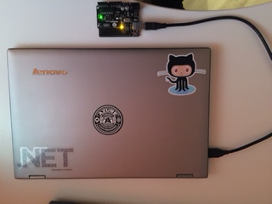

1. Launch  
   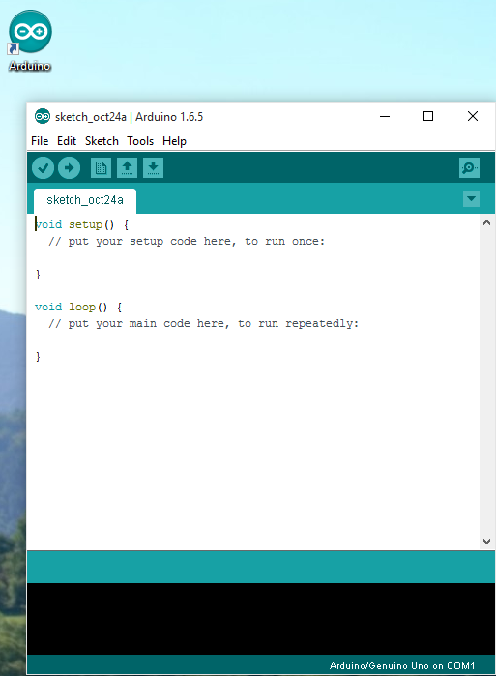
2. Select your port  
   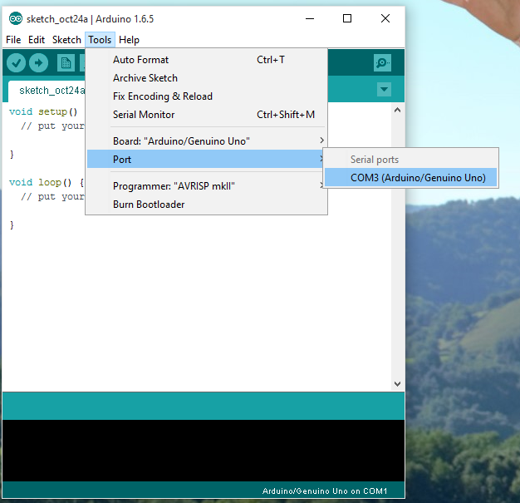
3. Upload a basic sketch  
   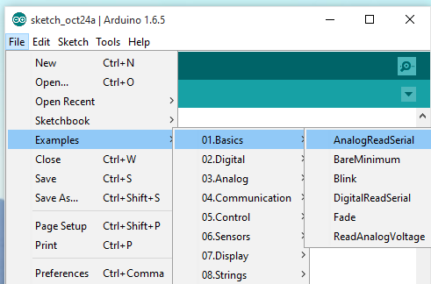  
   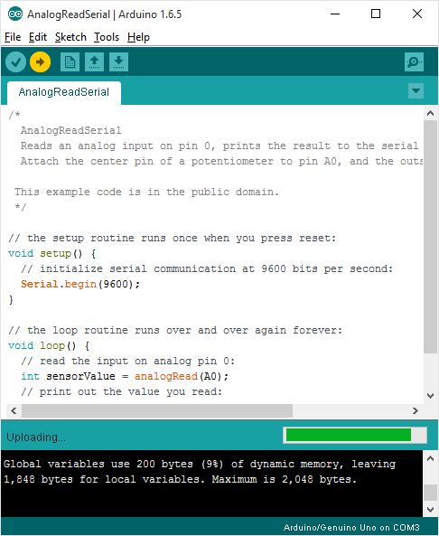
4. Open the Serial monitor

If you see this, it means that you’re ready to Go!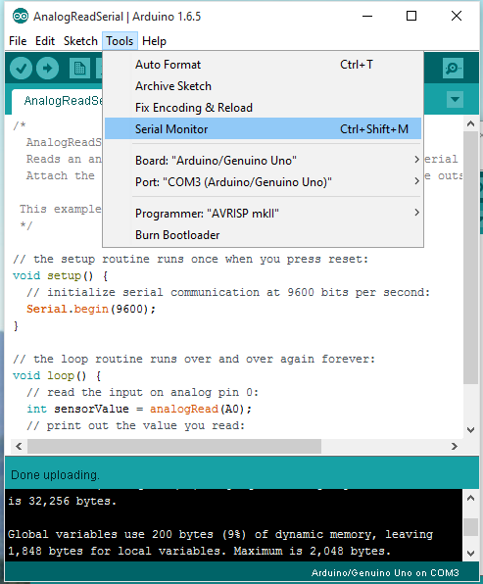

If you see this, it means that you’re ready to Go!  
